17.54: a) 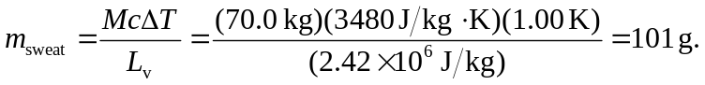
b) This much water has a volume of 101 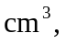about a third of a can of soda.

